**ESTIMATION OF BUSINESS EXPENSES**

**BACHELOR OF SCIENCE IN MATHEMATICS**

**TEAM ID** : **NM2023TMID35440**

**TEAM LEAD : Ms. N.KANIMOZHI**

**TEAM MEMBER :**

**Ms. M.GAYATHRI**

**Ms. T.GOWSALYA**

*Under the Guidance of*

**Ms. S. MOHANA PRIYA ., M.Sc., M.Phil .,**

Assistant Professor, Department of Mathematics



**DEPARTMENT OF MATHEMATICS**

**KSR COLLEGE OF ARTS AND SCIENCE FOR WOMEN**

**TIRUCHENGODE-637215**

**NAMAKKAL (DT), TAMILNADU.**

**ESTIMATION OF BUSINESS EXPENSES**

**1.INTRODUCTION**

**1.1 Overview**

This report delves into the fascinating realm of business expenses and provides a visual exploration of the various expenditures incurred by different businesses. It showcases the distribution of expenses, identifies key cost drivers, and highlights areas of potential optimization or concern. The visual representations allow for intuitive analysis, facilitating a deeper understanding of expenditure patterns and their implications for business performance. Decision-makers, financial analysts, and stakeholders can gain valuable insights into the financial health of businesses, identify areas of inefficiency or opportunity, and make informed decisions to optimize resources and drive growth. To Extract the Insights from the data and put the data in the form of visualizations, Dashboards and Story we employed Tableau tool.

**1.2 Purpose**

Estimates are documents that provide approximate costs for a project. Small businesses create them for potential clients so both parties are clear on the ins and outs of a project before it starts. Fresh Books has an estimates feature that help you build an estimate quickly and easily. The purpose of cost estimation is to predict the quantity, cost, and price of the resources required to complete a job within the project scope. Cost estimates are used to bid on new business from prospective clients and to inform your job and budget planning process.

**2. PROBLEM DEFINITION & DESIGN THINKING**

Creating empathy maps can be a powerful tool for customer journey mapping, but it's important to be aware of the common pitfalls and biases that can affect them. To avoid these, you should diversify your data sources, test your assumptions, segment your users, and encourage feedback and debate.

**2.1. Empathy Map**

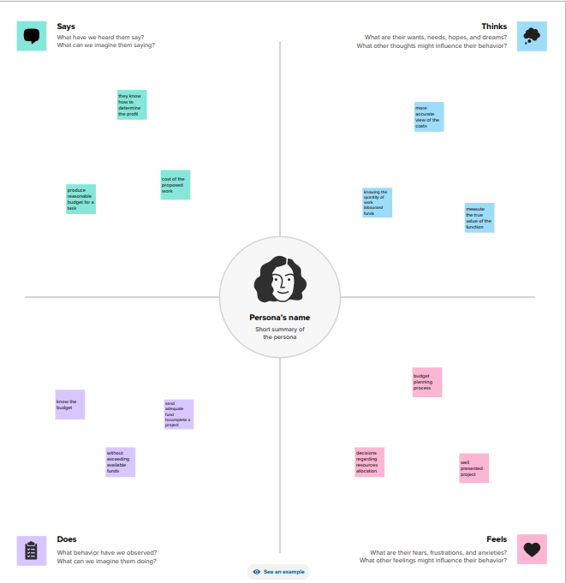

**2.2 Ideation & Brainstorming map**

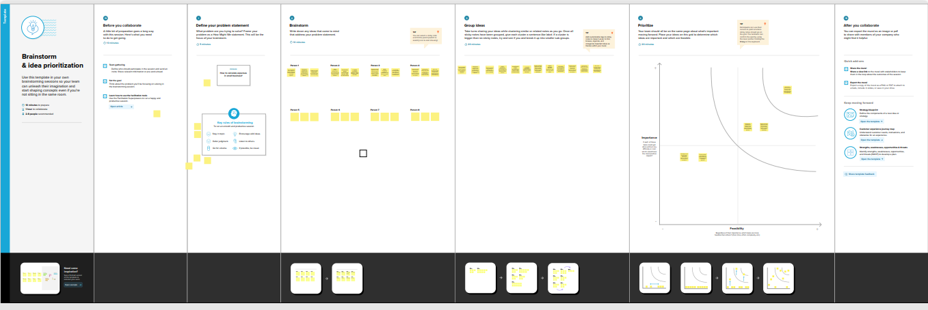

**3. RESULT**

**3.1 Sheets**

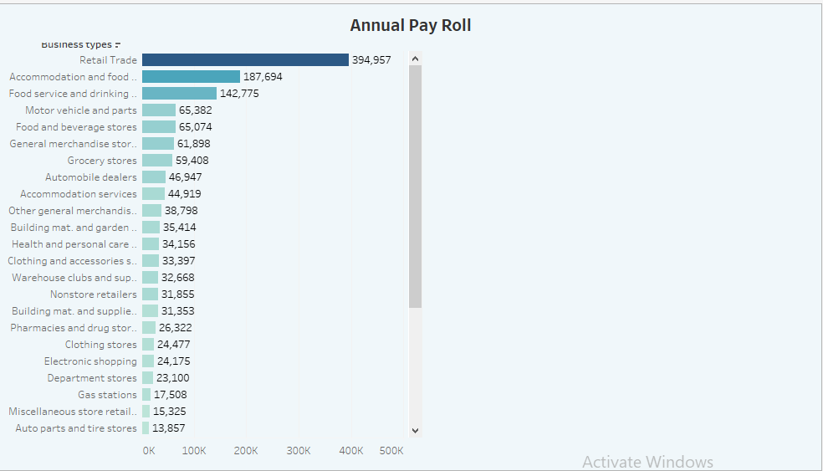

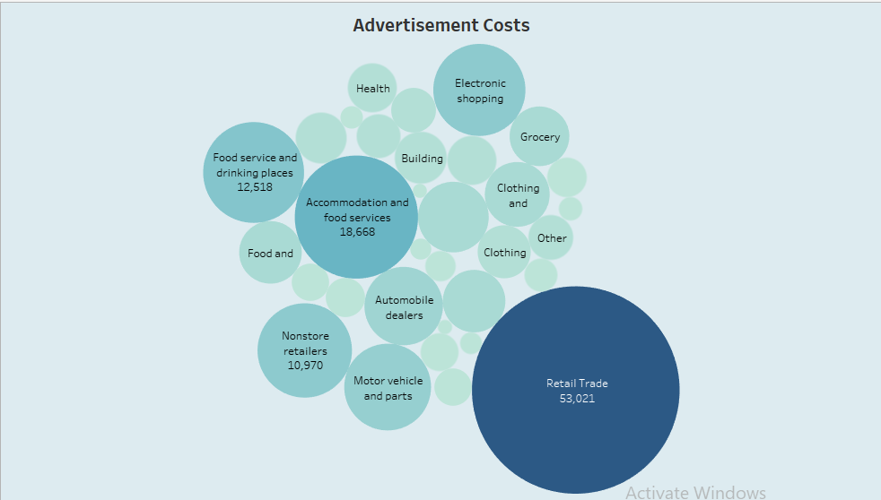

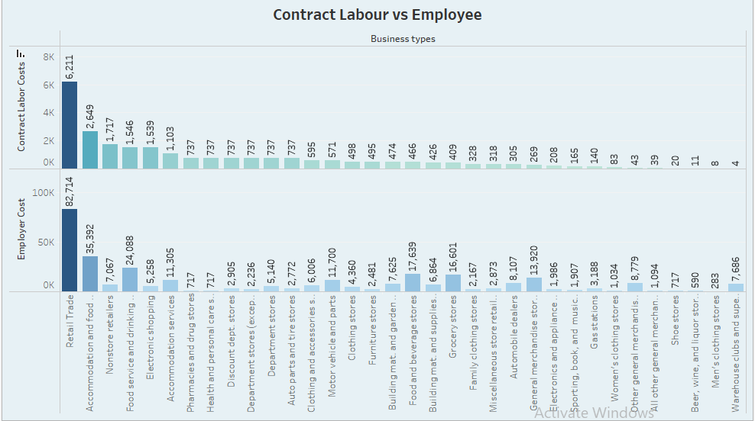

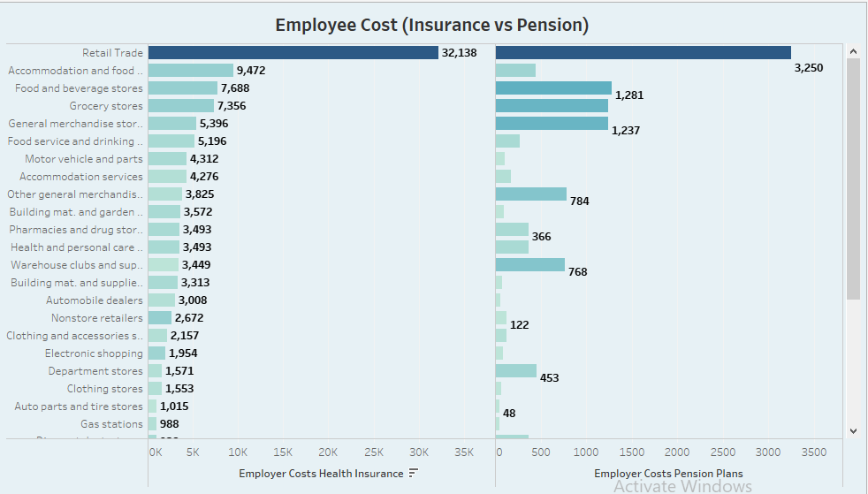

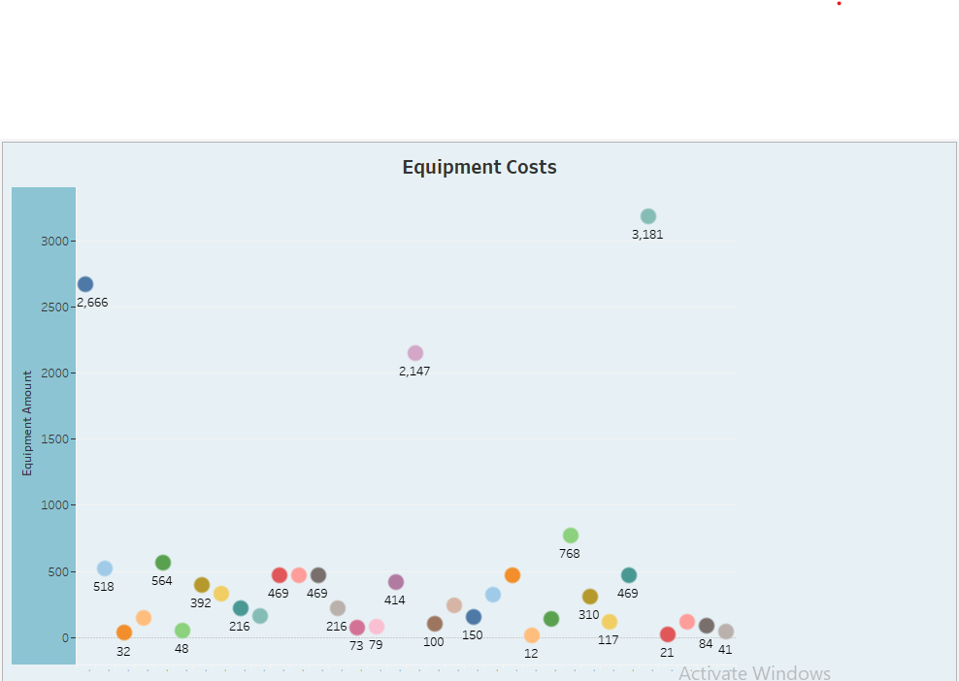

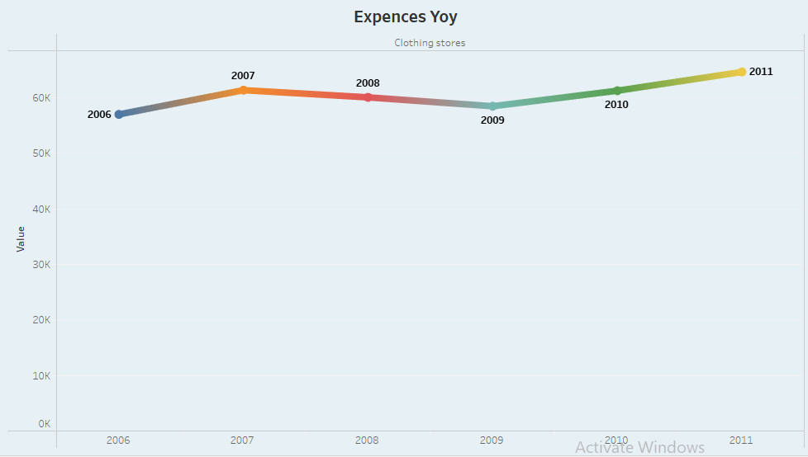

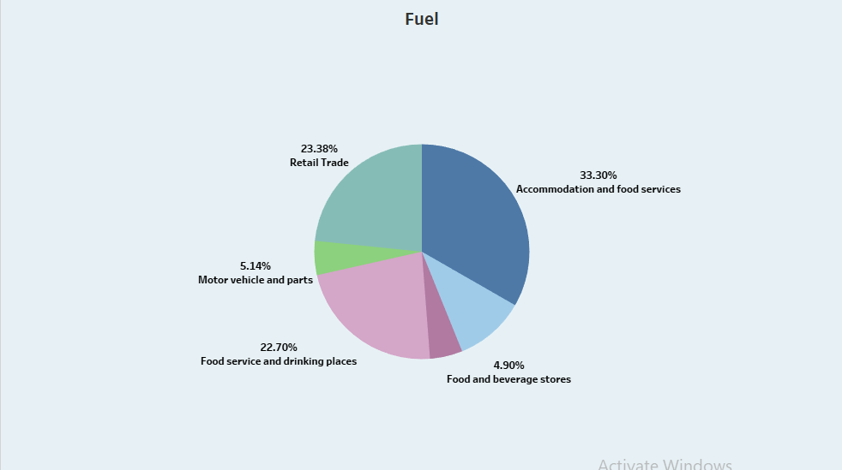

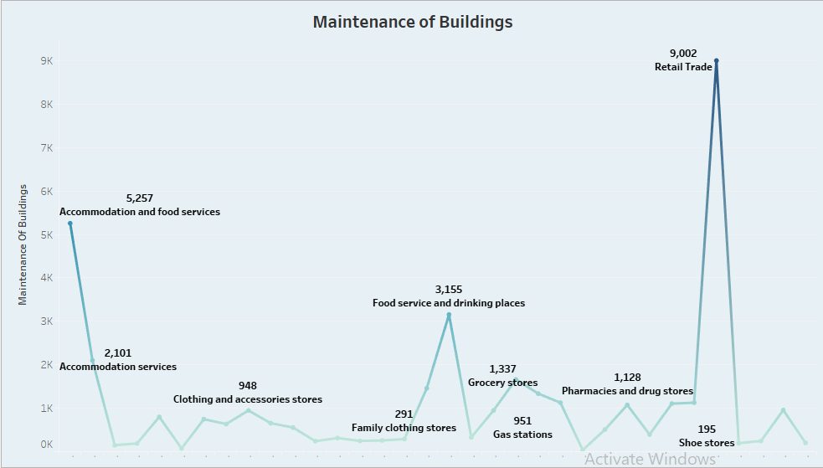

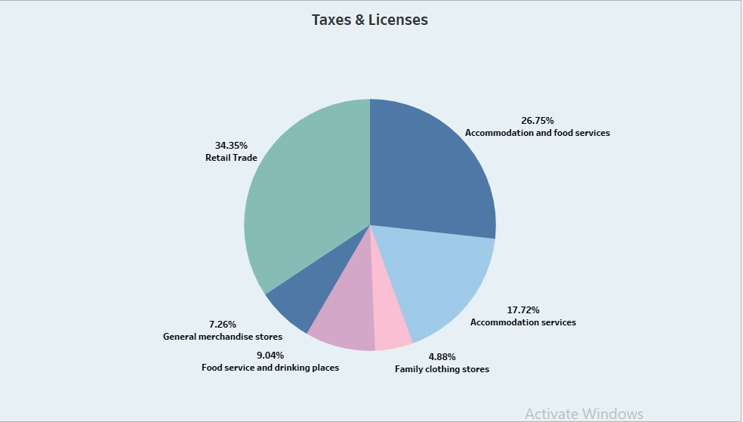

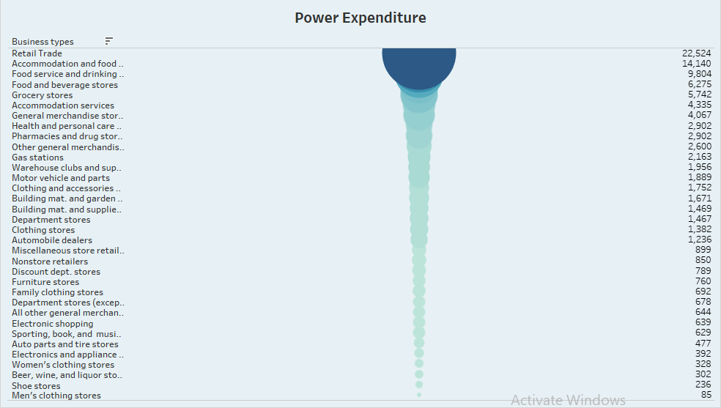

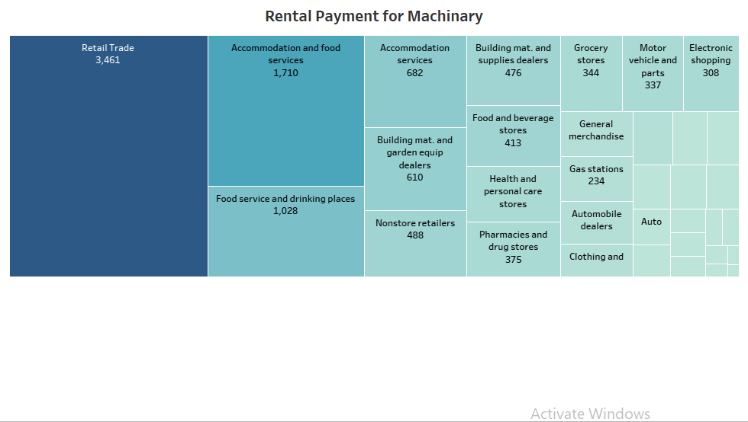

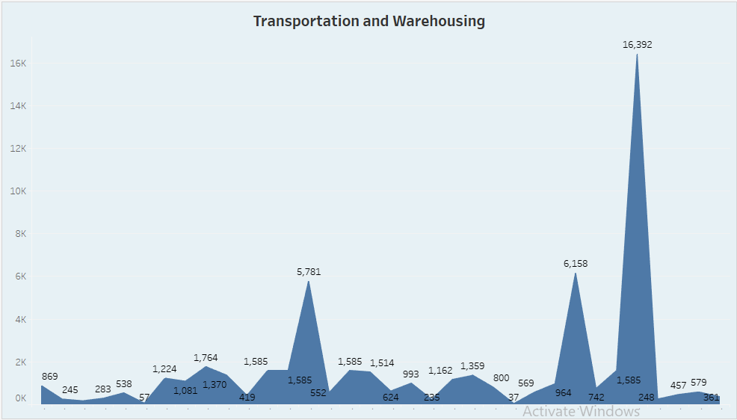

**3.2 Dashboard**

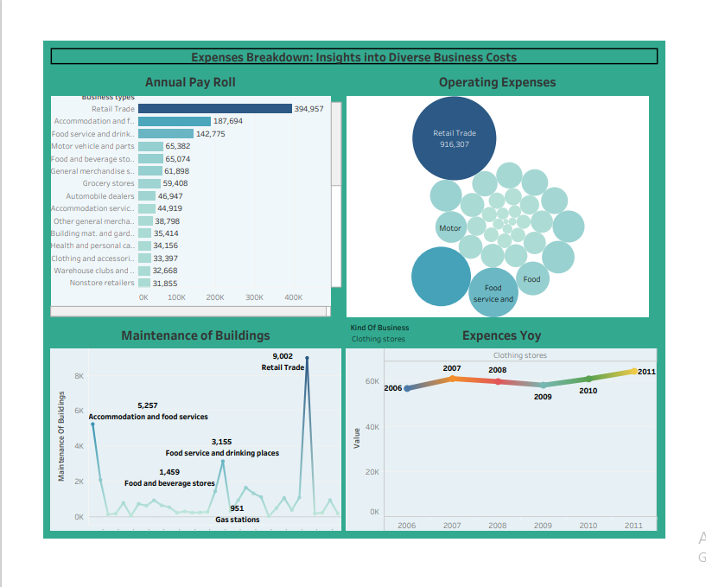

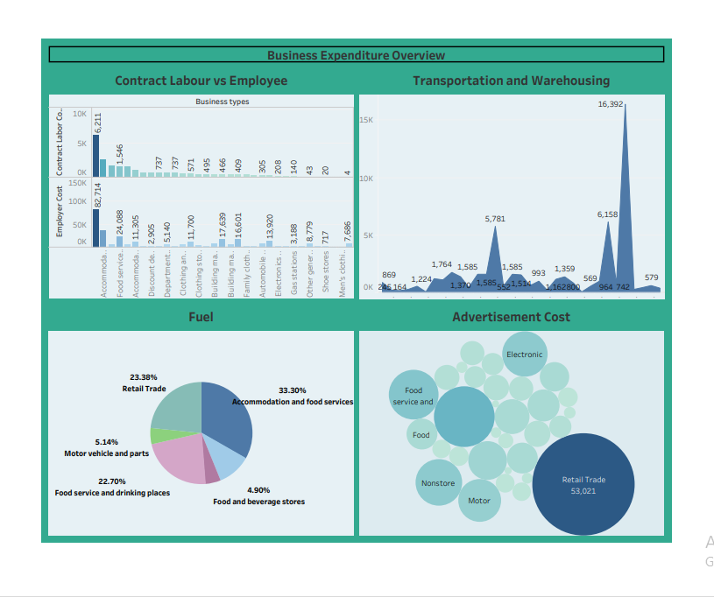

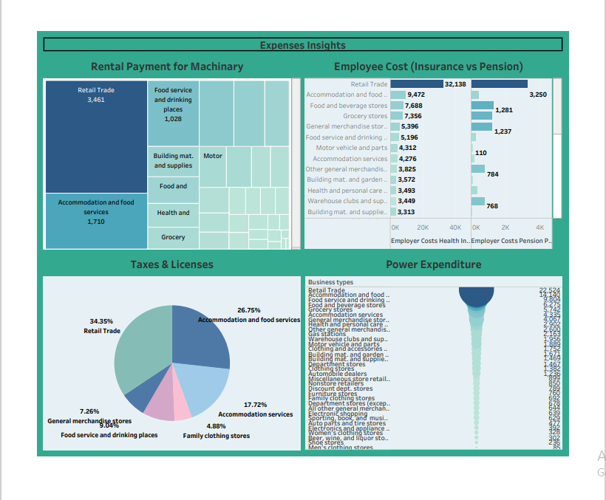

**3.3 Story**

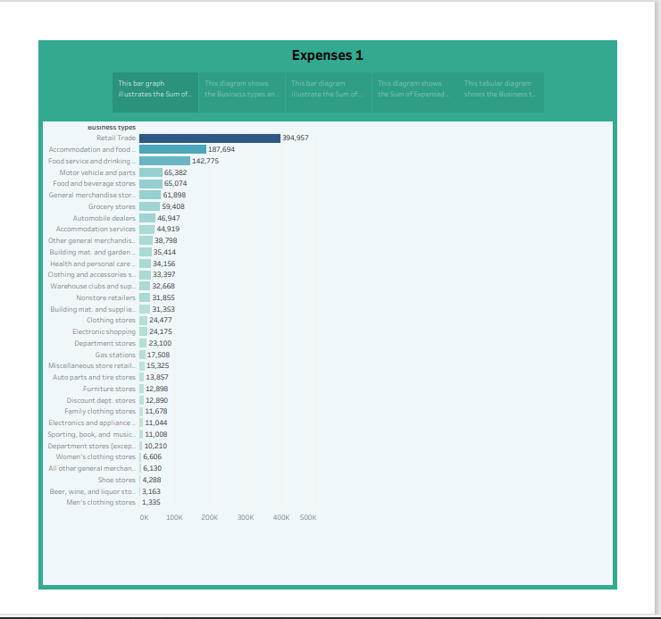

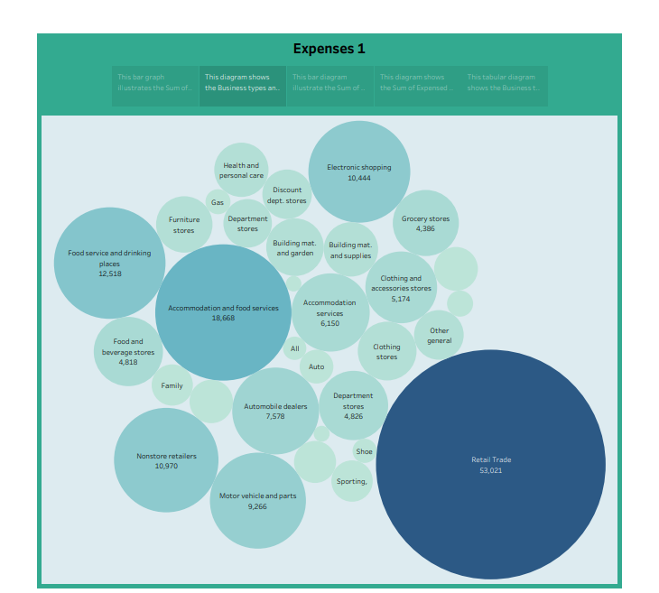

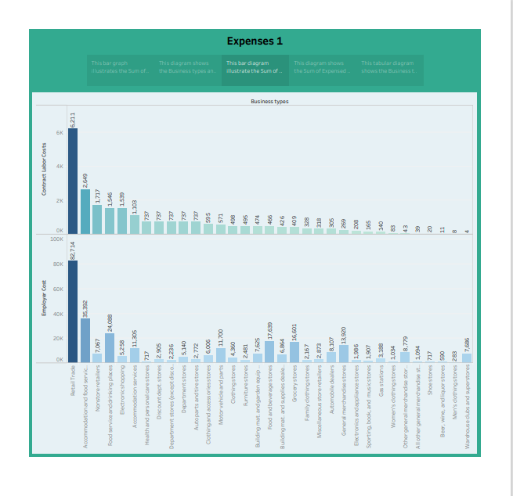

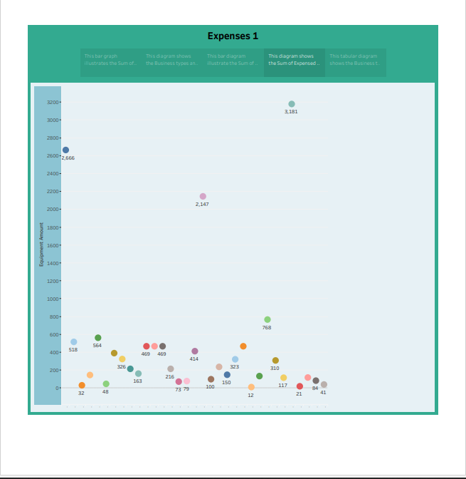

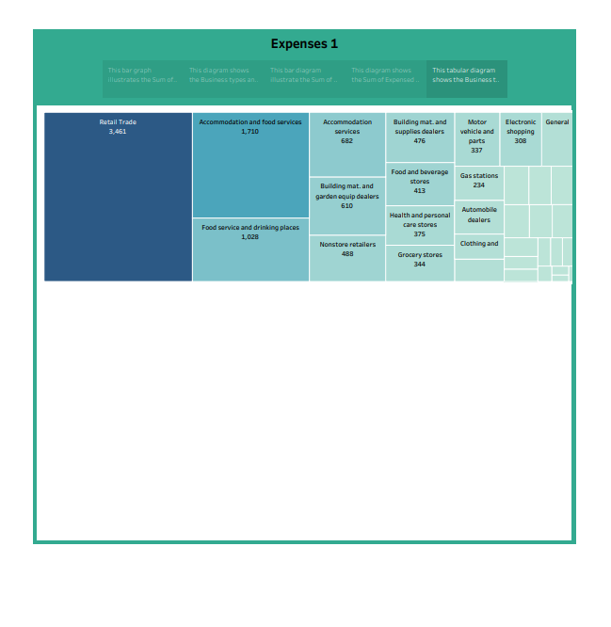

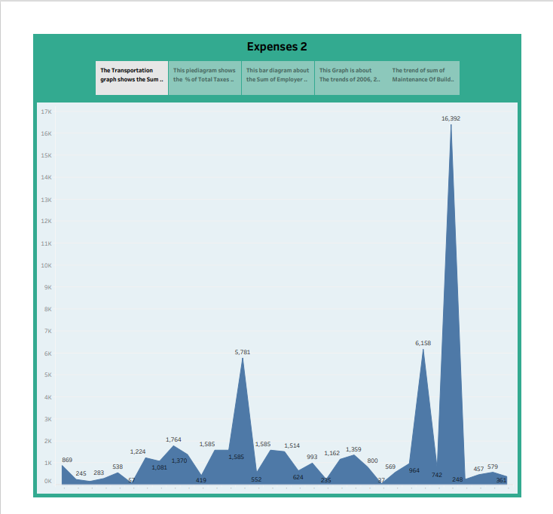

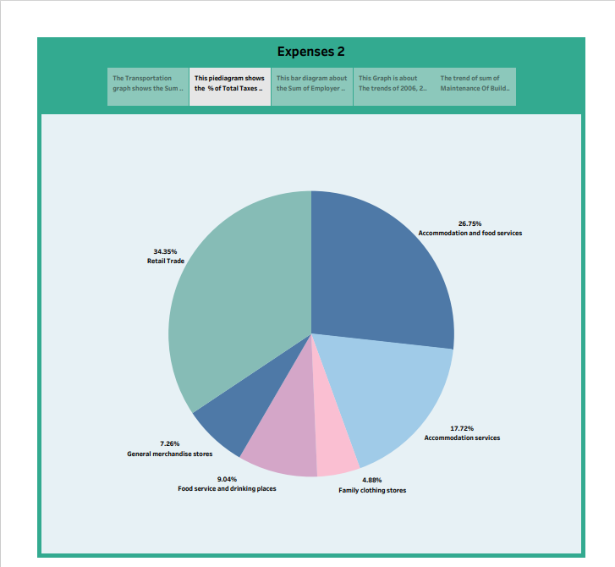

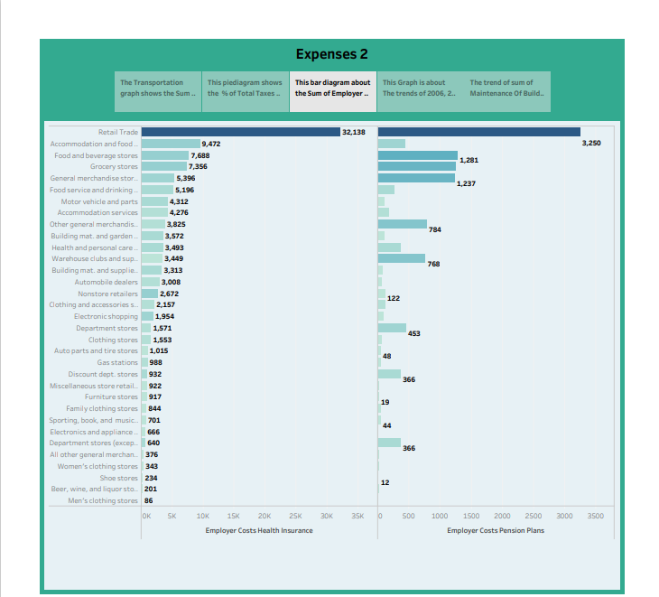

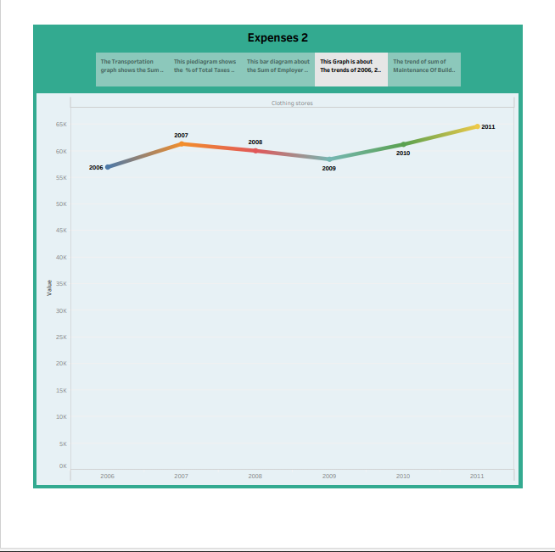

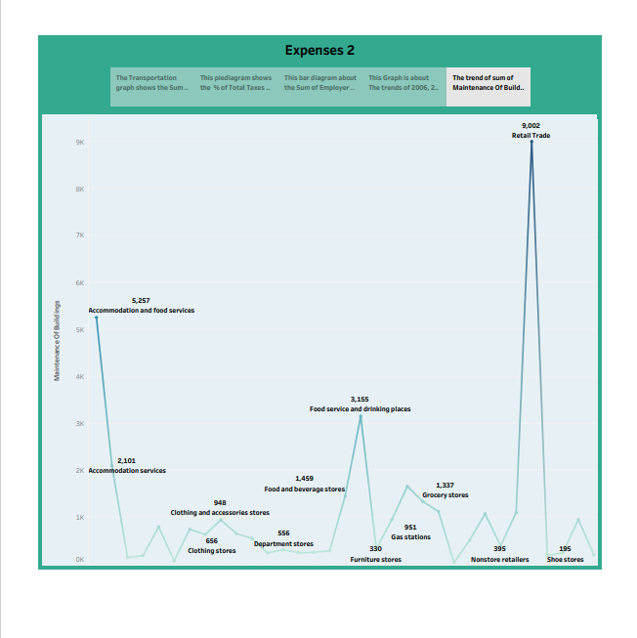

**4.ADVANTAGES & DISADVANTAGES**

**Advantages:**

Creative freedom and personal satisfaction. As a business owner, you'll be able to work in a field that you really enjoy. You'll be able to put your skills and knowledge to use, and you'll gain personal satisfaction from implementing your ideas, working directly with customers, and watching your business succeed.

**Disadvantages:**

The financial resources needed to start and grow a business can be extensive. You may need to commit most of your savings or even go into debt to get started. If things don't go well, you may face substantial financial loss. In addition, there's no guaranteed income.

**5.APPLICATIONS**

* Estimates are important because they allow businesses to set expectations for their customers. They also help businesses determine whether or not a project is feasible and how much profit they can expect to make. Estimating also allows businesses to plan for unforeseen expenses and keep track of spending.
* Cost estimation helps you determine your project's budget, schedule the work necessary and manage new resources. Cost estimates are also very crucial when it comes to winning new business. Property owners also use cost estimates to assess the feasibility of their projects before embarking on actual construction.
* Estimating business expenses is an important step in determining how much money you need to start and keep your business running without encountering cash flow problems. Every business has different requirements, depending on the type of products or services it sells, the size of the company, and the stage of growth of the business. Even so, most business expenses are either one-time costs or ongoing expenses required to keep operations going.

**6.CONCLUSION**

In the blog, we concluded that cost estimation is a vital process that involves predicting the financial requirements of a project or activity. It provides valuable insights that help you to make informed decisions, set budgets, allocate resources effectively, manage risks, and gain a competitive advantage. cost estimation is an important component of project management that ensures projects are finished on schedule and within budget. Since inaccurate cost estimates can have serious financial consequences for businesses, accurate cost estimating is crucial for all stakeholders engaged in a project

**7.FUTURE SCOPE**

Cost estimation in project management is the process of forecasting the financial and other resources needed to complete a project within a defined scope. Cost estimation accounts for each element required for the project from materials to labor and calculates a total amount that determines a project's budget.

Fixed expenses can be used to calculate several key metrics, including a company's breakeven point and operating leverage.